View Policies

**#1**

When no policies are registered with the system

Output:

**#2**

When policies are registered with the system

1. Active Licenses

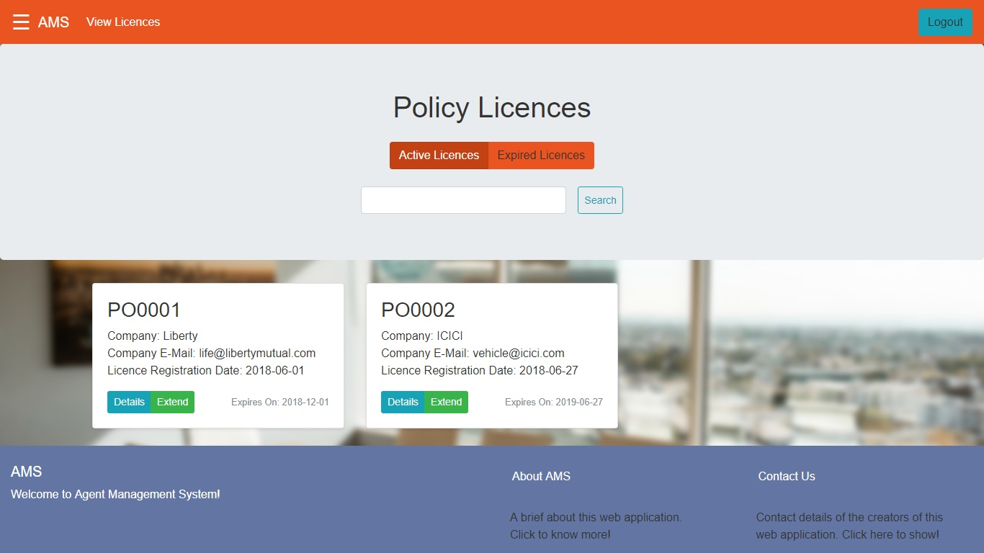

1. Expired Licenses

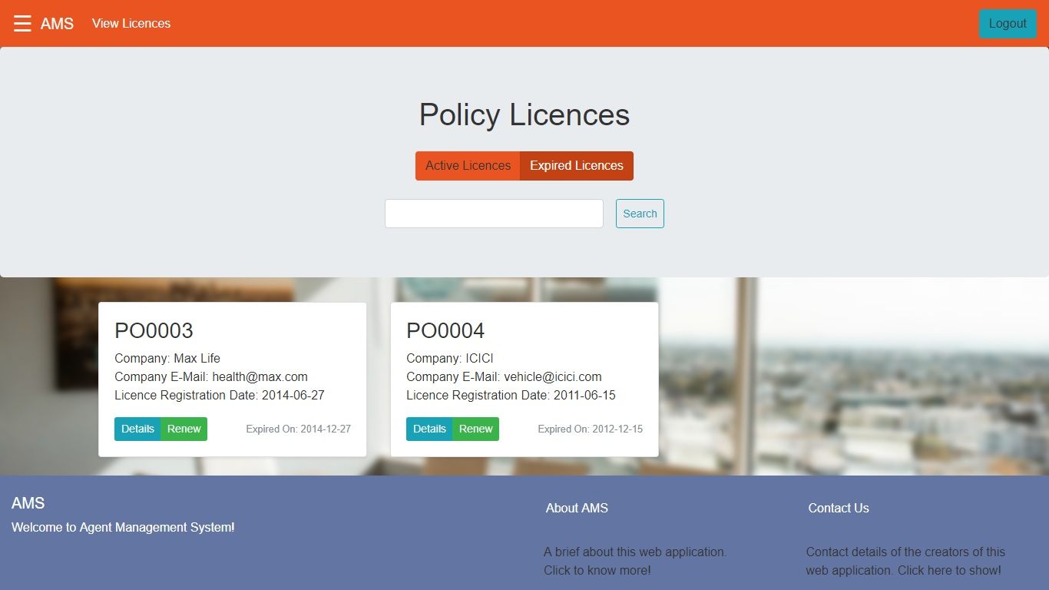

**#3**

View Policy Details

Output:

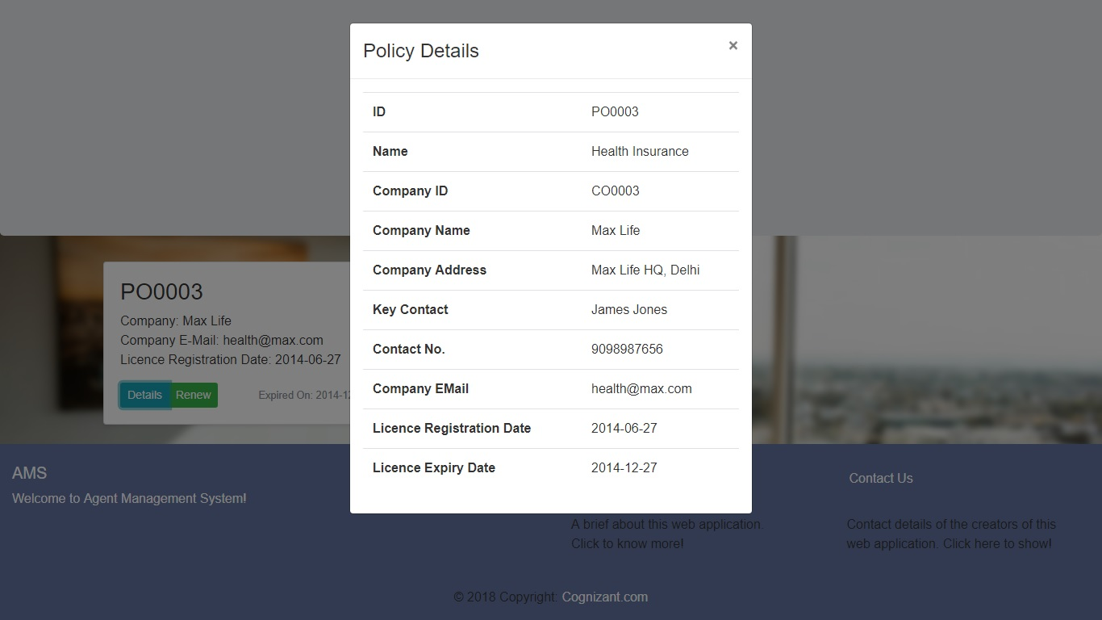

**#4**

Extend Active Licence

*Select Renewal Duration: 6 Months*

*Updated Expiry Date: 12/01/2019*

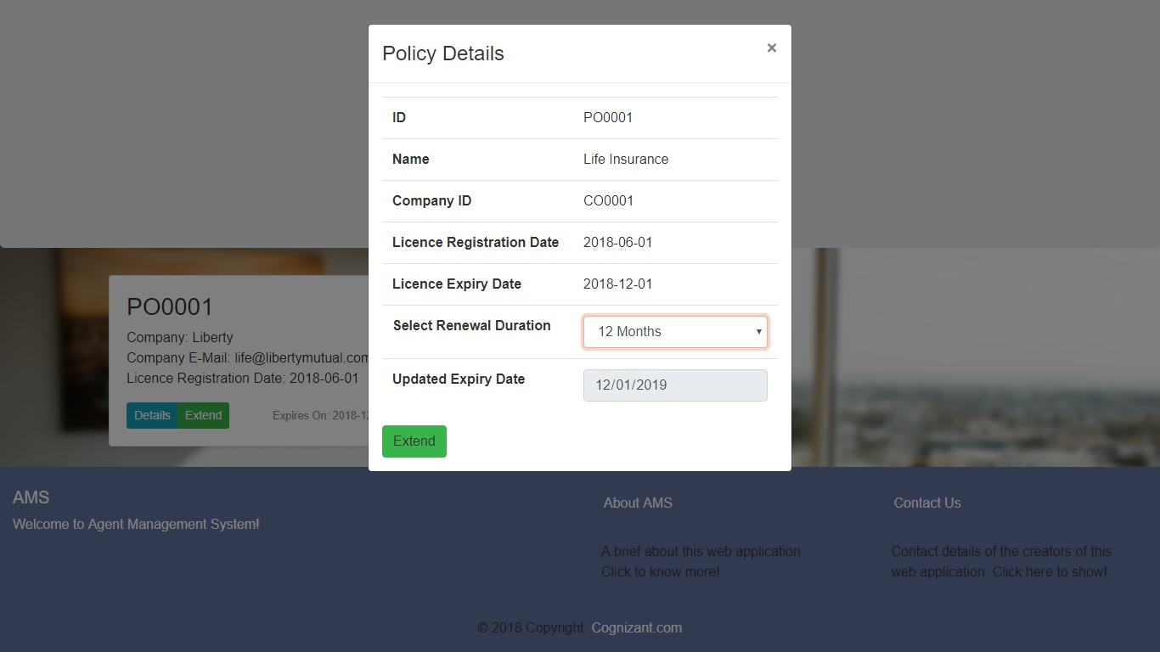

Output:

*The Licence has been renewed.*

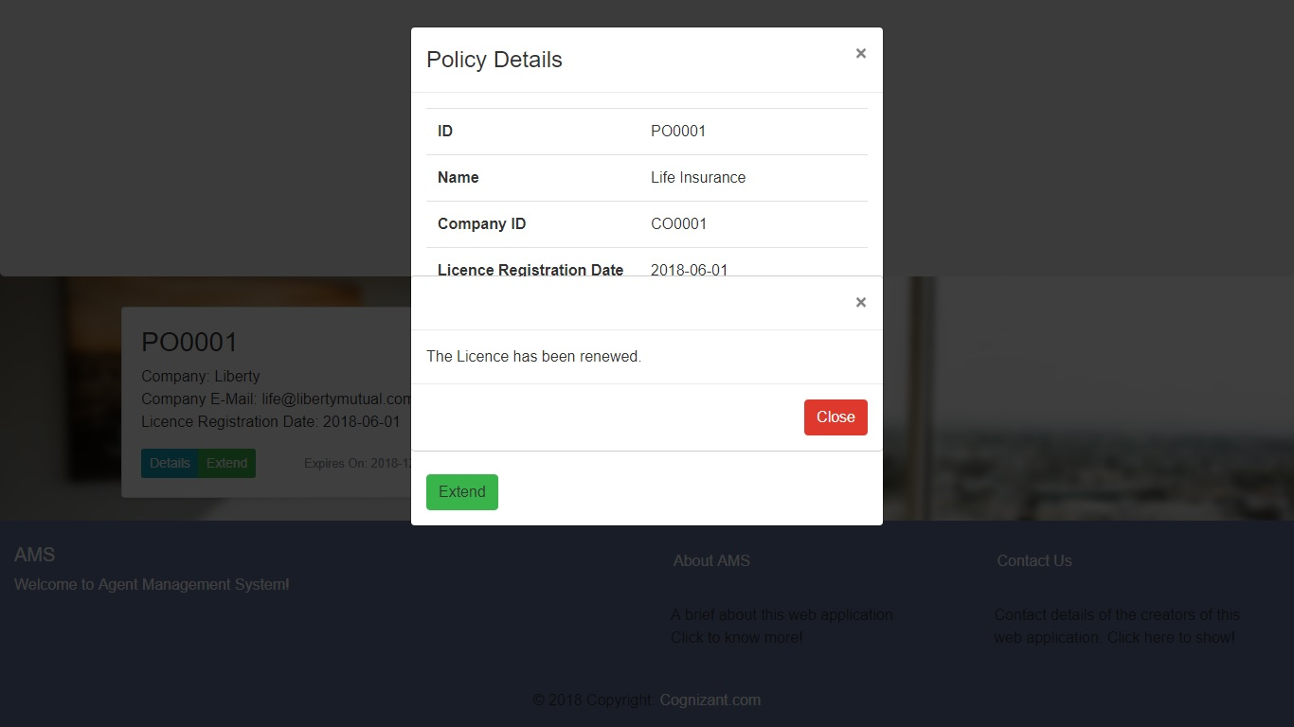

**#5**

Renew Expired Licence

*Select Renewal Duration: 12 Months*

*Updated Expiry Date: 11/27/2019*

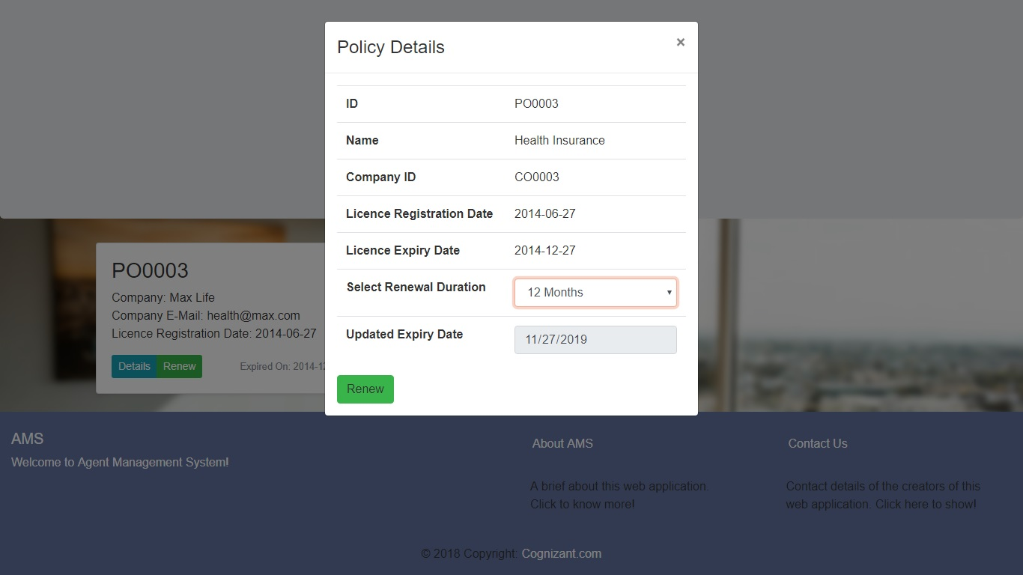

Output:

*The Licence has been renewed.*

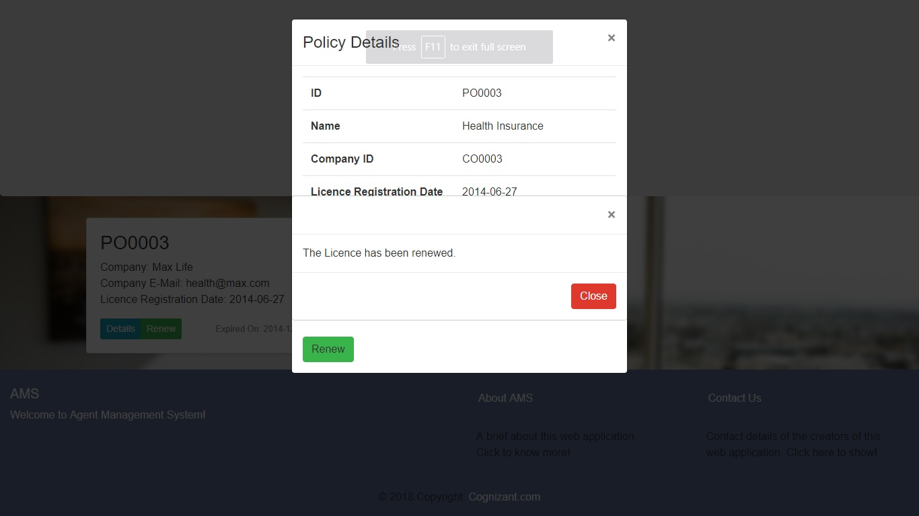

**#6**

Search By Policy Name

Key: vehicle

Output:

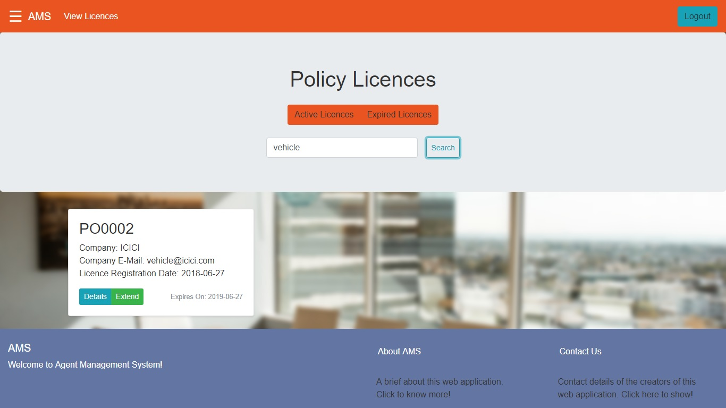

**#7**

Search By Company Name

Key: icici

Output:

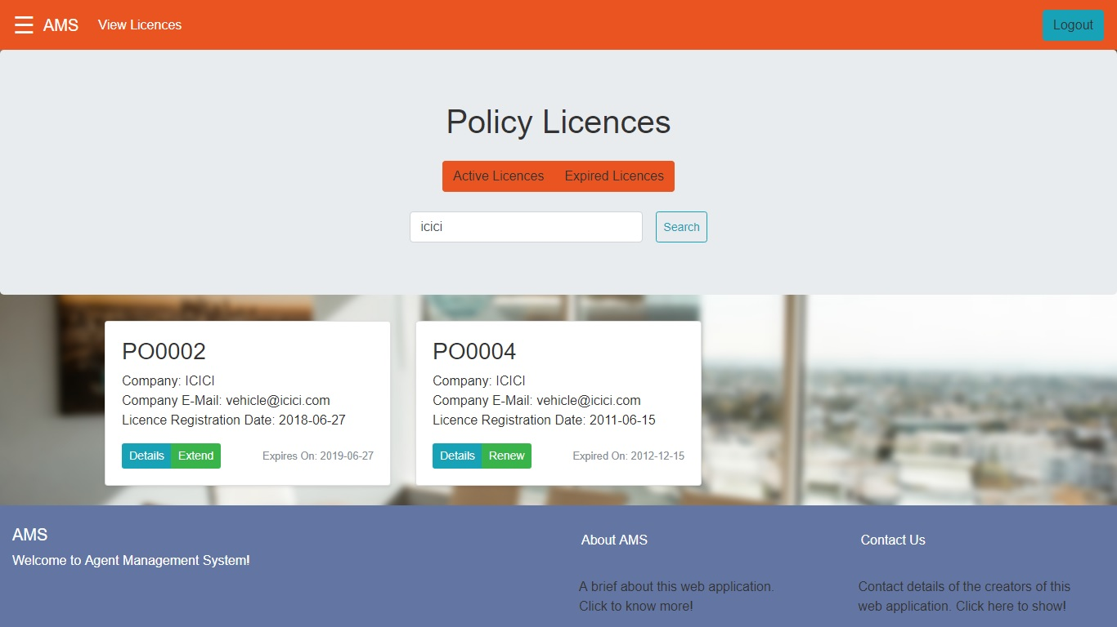

**#8**

Search By Company Id

Key: CO0003

Output:

